In the previous article we saw a step by step process of creating Visual Studio ItemTemplate and explored one option to install our compiled ItemTemplate into visual studio. If you are directly reading this article and haven’t ready the previous article I would strongly recommend you to go and read that article first as we are going to continue the same project and add one more project that will put our ItemTemplate in VSIX installer package. You find previous article at following location.

[Creating Custom Visual Studio 2010 ItemTemplate using "C# ItemTemplate"](http://www.a2zdotnet.com/View.aspx?Id=170)

Let’s being our effort to create VSIX package for our Visual Studio ItemTemplate we created in our previous article session. I am assuming that you already have this project created/downloaded locally and is compiling well. So with that base in mind let’s add one more project to your existing solution of type VSIX package as shown below.

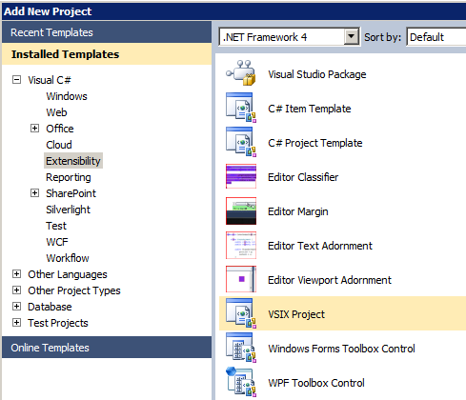

Now your solution should look something similar to following screen shot.

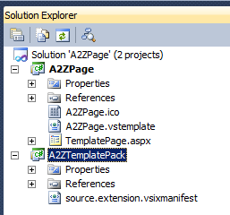

Next you have to open the .vsixmanifest file shown in above screen shot and provide properties according to your requirements something similar to what is show in screen shot below.

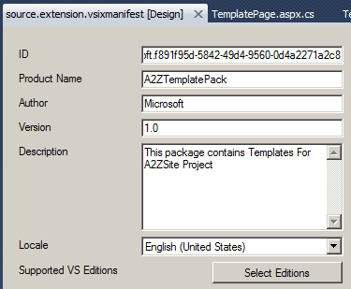

Next below this properties windows is the Content window as shown below. Go ahead and click on the “Add Content” button. Some selection dialog should pop up. Follow the series of screen shot to get an idea what you have to do.

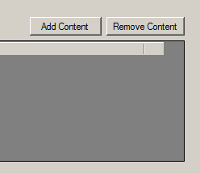

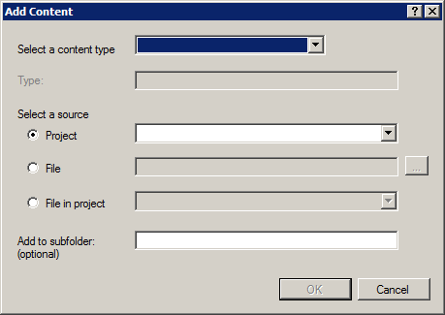

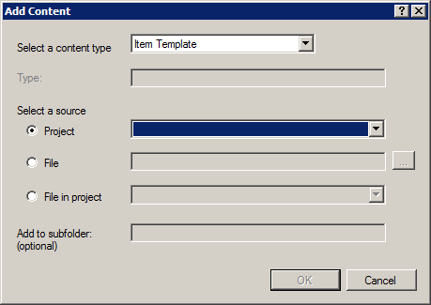

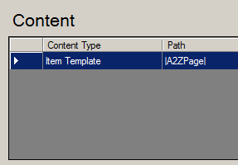

And that’s it. Now go ahead and compile the project and go to bin/debug folder of your VSIX project. You should have your VSIX package ready to be distributed.

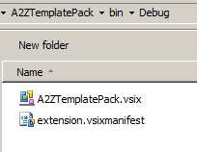

Next screen shot series shows you a step by step process to install this ItemTemplate using VSIX package and where to locate your own Visual Studio ItemTemplate.

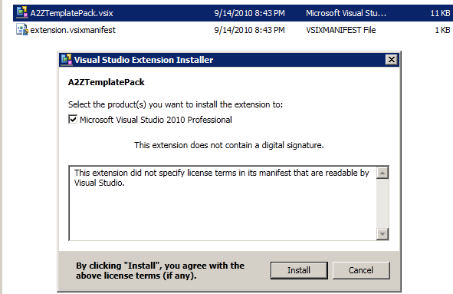

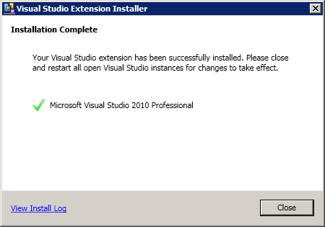

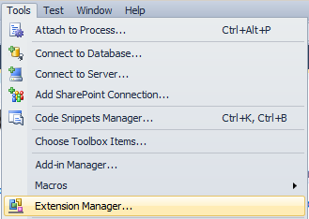

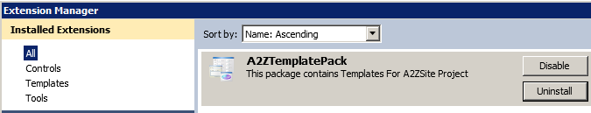

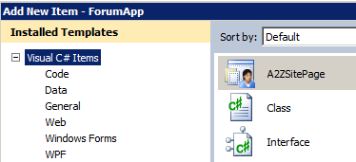

So to conclude what we learnt in this two article series is two things.

How to create Visual Studio ItemTemplate ?

How to create VSIX package and include ItemTemplate in that installer ?

Thanks.